Question 1:

#include <stdio.h>

int main()

{

int array[20], search, i, n;

printf("Enter number of elements in array\n");

scanf("%d", &n);

printf("Enter %d integers \n"

, n);

for (i = 0; i < n; i++)

scanf("%d", &array[i]);

printf("Enter a number to search\n");

scanf("%d", &search);

for (i = 0; i < n; i++)

{

if (array[i] == search) {

printf("%d is present at location %d.\n"

, search, i+1);

break;

}

}

if (i == n)

printf("%d isn't present in the array.\n"

, search);

} 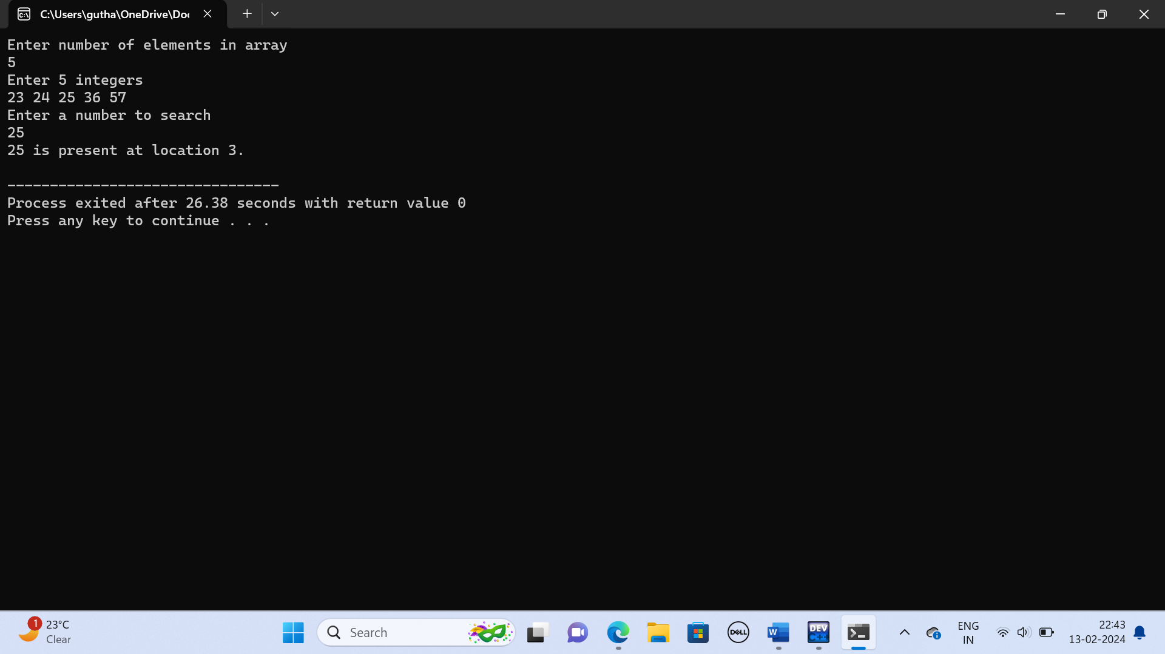

Question 2:

#include <stdio.h>

int main() {

int c, first, last, middle, n, search, array[100];

printf("Enter number of elements\n");

scanf("%d",&n);

printf("Enter %d integers\n", n);

for (c = 0; c < n; c++)

scanf("%d",&array[c]);

printf("Enter value to find\n");

scanf("%d", &search);

first = 0;

last = n - 1;

middle = (first+last)/2;

while (first <= last) {

if (array[middle] < search)

first = middle + 1;

else if (array[middle] == search) {

printf("%d found at location %d.\n", search, middle+1);

break;

}

else

last = middle - 1;

middle = (first + last)/2;

}

if (first > last)

printf("Not found! %d isn't present in the list.\n", search);

} 